ADAPTIVE BeamForming

Assignment 3: EEL 6935 - SPRING.2018 Hector Lopez 3-2-2018

## Problem 1

Use the Matrix Inversion Lemma (Woodbury’s identity) to derive a recursion for the inverse of the estimated input autocorrelation matrix ${\left[\hat{R}\left(k\right)\right]}^{-1}$ based on the sample average recursion

$$\left(1\right) \hat{R}\left(k\right)=\frac{\left(k-1\right)*\hat{R}\left(k-1\right)+r_{k}r_{k}^{H}}{k}$$

where $r_{k}, k=1,2,…,$ are the array input vectors.

Let’s recall the Woodbury Identity.

Given: $A_{MxM},B_{MxM},C_{MxL},D_{LxL}$ assume that A,B,D, are invertible.

If $A= B^{-1}+CD^{-1}C^{H}$;

Then $A^{-1}= B-BC{(D+C^{H}BC)}^{-1}+C^{H}B$

By direct multiplication the Woodbury Lemma shows:

$\left(AA^{-1}=…=I\right)$ and $\left(A^{-1}A=…=I\right)$

Lets first re-write our equation (1) so that it is in the form of the Woodbury formula. We will have to move the scalar (1/k) and remember to multiply our inverted matrix by it at the end.

$$\left(2.1\right) \hat{R}\left(k\right)=\frac{\left(k-1\right)}{k}*\hat{R}\left(k-1\right)+\frac{1}{k}*{\overset{⃑}{r}}_{k}{\overset{⃑}{r}}_{k}^{H}$$

$$\left(2.2\right) k*\hat{R}\left(k\right)=\left(k-1\right)*\hat{R}\left(k-1\right)+{\overset{⃑}{r}}_{k}{\overset{⃑}{r}}_{k}^{H}$$

We can now define the matrices that we will use in the inversion formula.

$$\left(3\right) A=\hat{R}\left(k\right) , B^{-1}=\left(k-1\right)*\hat{R}\left(k-1\right), C={\overset{⃑}{r}}_{k}, D^{-1}=1$$

These matrices can be used in the lemma to define our inverse A matrix.

$$\left(4\right) A^{-1}= B-BC{(D+C^{H}BC)}^{-1}+C^{H}B$$

$${\left(5.1\right) \hat{R}\left(k\right)}^{-1}=inv\left[\left(k-1\right)*\hat{R}\left(k-1\right)\right]-inv[\left(k-1\right)*\hat{R}\left(k-1\right)]{\overset{⃑}{r}}_{k}{\left(1+{{\overset{⃑}{r}}_{k}}^{H}inv[\left(k-1\right)*\hat{R}\left(k-1\right)]{\overset{⃑}{r}}_{k}\right)}^{-1}+{{\overset{⃑}{r}}_{k}}^{H}inv[\left(k-1\right)*\hat{R}\left(k-1\right)]$$

$${\left(5.2\right) \hat{R}\left(k\right)}^{-1}=\frac{1}{(k-1)}*{\hat{R}\left(k-1\right)}^{-1}-\frac{1}{\left(k-1\right)}*{\hat{R}\left(k-1\right)}^{-1}{*\overset{⃑}{r}}_{k}{\left(1+{{\overset{⃑}{r}}_{k}}^{H}*\frac{1}{\left(k-1\right)}*{\hat{R}\left(k-1\right)}^{-1}*{\overset{⃑}{r}}_{k}\right)}^{-1}+{{\overset{⃑}{r}}_{k}}^{H}*\frac{1}{(k-1)}*{\hat{R}\left(k-1\right)}^{-1}$$

$$\left(5.3\right) {\hat{R}\left(k\right)}^{-1}=\frac{1}{(k-1)}*\left[{\hat{R}\left(k-1\right)}^{-1}-\frac{{\hat{R}\left(k-1\right)}^{-1}{*\overset{⃑}{r}}_{k}{{\overset{⃑}{r}}_{k}}^{H}*{\hat{R}\left(k-1\right)}^{-1}}{\left(k-1\right)+{{\overset{⃑}{r}}_{k}}^{H}{*\hat{R}\left(k-1\right)}^{-1}{*\overset{⃑}{r}}_{k}}\right]$$

We need to add the scalar we had before the Woodbury lemma was applied.

$$\left(6.1\right) k*{\hat{R}\left(k\right)}^{-1}=\frac{1}{(k-1)}*\left[{\hat{R}\left(k-1\right)}^{-1}-\frac{{\hat{R}\left(k-1\right)}^{-1}{*\overset{⃑}{r}}_{k}{{\overset{⃑}{r}}_{k}}^{H}*{\hat{R}\left(k-1\right)}^{-1}}{\left(k-1\right)+{{\overset{⃑}{r}}_{k}}^{H}{*\hat{R}\left(k-1\right)}^{-1}{*\overset{⃑}{r}}_{k}}\right]$$

$$\left(6.2\right) {\hat{R}\left(k\right)}^{-1}=\frac{1}{k*(k-1)}*\left[{\hat{R}\left(k-1\right)}^{-1}-\frac{{\hat{R}\left(k-1\right)}^{-1}{*\overset{⃑}{r}}_{k}{{\overset{⃑}{r}}_{k}}^{H}*{\hat{R}\left(k-1\right)}^{-1}}{\left(k-1\right)+{{\overset{⃑}{r}}_{k}}^{H}{*\hat{R}\left(k-1\right)}^{-1}{*\overset{⃑}{r}}_{k}}\right]$$

Finally, the equation (6.2) shows the final inversion as a recursive function in terms of the $k$, the input vector instance and the previous inversion value to get the new inversion value. This recursive formula needs to be initialized. We can initialize it with ${\hat{R}\left(0\right)}^{-1}=c*I$ Where I is the identity matrix and for some c << 1.

## Problem 2

Show that,

$$\left(7\right) α_{1}≜ \frac{α_{1}^{'}}{{SINR}_{opt}*\left(1-α_{1}^{'}\right)+1}$$

where SINRopt is the maximum attainable SINR by the antenna array and $α_{1}$, $α_{1}^{'}$ are as deﬁned in the lectures.

We are examining the signal present adaptive beamformer versus the signal absent adaptive beamformer by analyzing the SINR of each, versus the optimal SINR of a beamformer given some linear antenna array.

$$\left(1\right) α_{1}=\frac{{SINR}_{1}}{{SINR}_{opt}}= \frac{{\left({{\overset{⃑}{S}}_{θ}}^{H}*{\hat{R}}^{-1}*{\overset{⃑}{S}}_{θ}\right)}^{2}}{\left({{\overset{⃑}{S}}_{θ}}^{H}*R_{I+N}*{\overset{⃑}{S}}_{θ}\right)\left({{\overset{⃑}{S}}_{θ}}^{H}*{\hat{R}}^{-1}*R_{I+N}*{\hat{R}}^{-1}*{\overset{⃑}{S}}_{θ}\right)}$$

$$\left(2\right) α_{2}=\frac{{SINR}_{2}}{{SINR}_{opt}}= \frac{{\left({{\overset{⃑}{S}}_{θ}}^{H}*{{\hat{R}}_{I+N}}^{-1}*{\overset{⃑}{S}}_{θ}\right)}^{2}}{\left({{\overset{⃑}{S}}_{θ}}^{H}*{R_{I+N}}^{-1}*{\overset{⃑}{S}}_{θ}\right)\left({{\overset{⃑}{S}}_{θ}}^{H}*{{\hat{R}}_{I+N}}^{-1}*{R_{I+N}}^{-1}*{{\hat{R}}_{I+N}}^{-1}*{\overset{⃑}{S}}_{θ}\right)}$$

We notice that there is no direct way to solve for the PDF of $α_{1}$ because there are two types of matrices in the denominator, ${\hat{R}}^{-1}$, ${{\hat{R}}_{I+N}}^{-1}$ for the eq.1 . Let’s define another version of $α_{1}$. by replacing the inversed sampled disturbance matrix, ${{\hat{R}}_{I+N}}^{-1}$ with ${\hat{R}}^{-1}$ in eq.1. This creates a new formula of the ratio $α_{1}^{'}$. The resulting equation is similar to $α_{2}$. The two formulas are almost identical in form with the difference being the swap between the disturbance matrix and the input signal autocorrelation matrices. Since the two matrices, ${\hat{R}}^{-1}$, ${{\hat{R}}_{I+N}}^{-1}$, have the same distribution, the ratios of $α_{1}'$ and $α_{2}$ also have the same distribution.

$$α_{1}^{'}\sim α_{2} (identically distributed)$$

$$\left(8\right) E\left\{α_{1}^{'}\right\}=E\left\{α_{2} \right\}$$

The denominator of the right hand side can be evaluated to always be greater than zero. We can prove this by first observing that the random variable $α_{1}^{'}$ is a ratio of the SINR’s that ranges from zero to one.

$${0≤α}_{1}^{'}≤1$$

The next observation is that the SINRopt is also a ratio of the signal and the disturbances, noise and interference, so it will be greater than 0.

$${SINR}_{opt}>0$$

We can prove by solving for the limits of the variables that the expression will remain as a positive value.

$${SINR}_{opt}*\left(1-α_{1}^{'}\right)+1>0$$

$${SINR}_{opt}*\left(1-α_{1}^{'}\right)+1>{SINR}_{opt}+1∵ α_{1}^{'}>0$$

$$0*\left(1-α_{1}^{'}\right)+1=1 ∵ {SINR}_{opt}=0$$

$${SINR}_{opt}*\left(0\right)+1=1∵ α_{1}^{'}=1$$

The optimal SINR should be much larger than 0, so if the SINRopt value gets larger. We can also observe that as we reduce the value of $α_{1}^{'}$ the largest value $α_{1}$ can achieve is also reduced proportionally.

$$\left(9\right) α_{1}≜ \frac{α_{1}^{'}}{{SINR}_{opt}*\left(1-α_{1}^{'}\right)+1}≪ α_{1}^{'}$$

In conclusion given the statement (eq.9) the random variable of $α_{1}$ will always be less than $α_{1}^{'}$ and similarly will always be less than $α_{2}$ since the mean of $E\left\{α_{1}^{'}\right\}=E\left\{α_{2} \right\}$.

## Problem 3

3. Design a simulation to estimate $E\left\{α_{1}\right\}$, $E\left\{α_{2}\right\},E\left\{α_{3}\right\}$:

Consider BPSK transmissions of one user of interest and three interferers.

Assume M = 10 and arbitrary in (-90,90) but ﬁxed angles of arrival.

$$BPSK=\overset{⃑}{r}= \sqrt{E_{1}}*b_{1}*{{\overset{⃑}{S}}_{θ}}_{1}+ \sum_{k=2}^{4}{\sqrt{E_{k}}*b_{k}*{{\overset{⃑}{S}}_{θ}}_{k}}+\overset{⃑}{n}$$

$$where b=±1$$

Data Generation :

Set reasonable SNR values for user and interference signals. Also set specific angles of arrival for each of these signals.

|  |  |
| --- | --- |
| **SNR** | **Theta** |
| 12dB | 80 |
| 13dB | 50 |
| 14dB | -50 |
| 15dB | -80 |

If we consider that the SNR of a signal is equivalent to the following expression:

$${SNR}_{i}=\frac{P_{signal}}{P_{noise}}=\frac{{A_{i}}^{2}}{σ_{noise}^{2}}$$

We can derive the power of each of our BPSK signals given the SNR value we defined in our table. We can solve for the power of the signal and find that the E is equal to the SNR value converted from decibels to power times the variance of the noise. If we set the noise variance to 1 because it is a gaussian distributed zero mean noise. Then we can solve for the power of each signal as a function of SNR.

$$\sqrt{E_{i}}=\sqrt{10*log10({SNR}_{i})*σ_{noise}^{2}}$$

$$E_{i}=10*log10({SNR}_{i})$$

|  |  |
| --- | --- |
| **SNR** | **E** |
| 12dB | 10.7918 |
| 13dB | 11.1394 |
| 14dB | 11.4613 |
| 15dB | 11.7609 |

We need to create binary data streams for each signal. Let’s use the normal distribution random variable from 0 to 2 then split the values in Matlab to generate the binary +1 or -1 vectors. We would need to do something similar for the noise vector in order to get a white gaussian noise vector of M elements with zero mean and a variance of 1.

Lastly, we need to construct the array response vector for the given thetas. We will use Nyquist spacing for our antenna elements and assume an arbitrary carrier frequency. The S_theta is a vector of Mx1 of complex values.

All of the components for the received signal are derived at every iteration of N. The received signals are used as a large set to calculate the autocorrelation matrix and the disturbance matrix. The data generation will need to occur repeatedly for each sample of N then overall the samples create the variables needed to calculate the single alpha value for the set of N samples. We will re-run the entire experiment for different sized batches of N. Recording the alpha at each batch size, we will be able to trend how alpha changes based on increases in record size.

The formulas for the signal present and signal absent beam formers come from estimates of the auto-correlation of the received signals.

$${\hat{\overset{⃑}{w}}}_{1}={\hat{R}}^{-1}* {\overset{⃑}{S}}_{θ}$$

$${\hat{\overset{⃑}{w}}}_{2}={{\hat{R}}_{I+N}}^{-1}* {\overset{⃑}{S}}_{θ}$$

So the simulation will use the record size as the record size grows to create the ${\hat{R}}_{}$ and ${\hat{R}}_{I+N}$.The use of $R_{I+N}$ and $R$ are needed in the formulas for the alpha’s so in order to create them the full sample record size of 200 will be used and all the generated received signals will be used to create the optimal auto-correlation matrix and the optimal disturbance matrix. By calculating the performance equation with the record size N a random variable for alpha would be given. Run the simulation sufficiently to get an estimate for alpha. Also this will be done at every record size between 10 and 200 . The following graph shows the result:

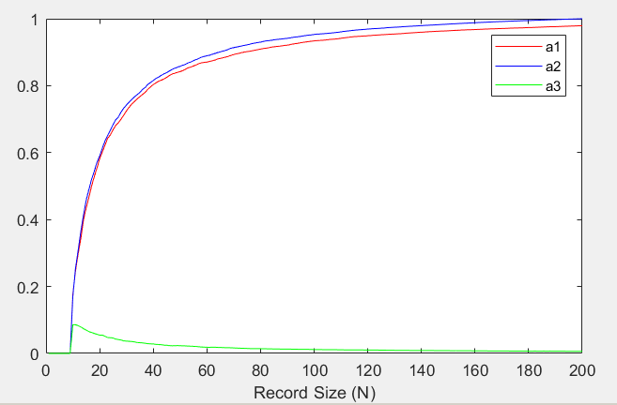

To verify the output of the program we can use the proof for the expected value of a2 derived from the incomplete beta distribution.

$$E\left\{α_{2} \right\}=\frac{N+2-M}{N+1} , when (N>M-3)$$

Mapping out the estimate against our simulation output we can see that the simulation is very close to our theoretical average.

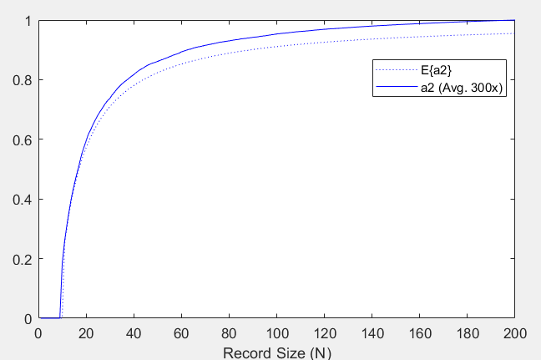

The exercise shows how the performance of alpha2 is greater than alpha1 this coincides with the mathematical proof described in part 2 of this assignment. The performance of alpha3 seemed to do poorly. The calculations for the alpha3 performance used the desired signal for each received signal. The implementation could of caused the performance calculated to be effected. The theorized performance of alpha3 would be that it performs better than alpha1 because it is capable of adjusting for error between the input and desired signals.

1. ***Keep the SNRs of the interferences as in Part (a) and plot the estimated means of α1, α2, and α3 as a function of the SNR of the user of interest for N = 10,50,100,200.***

So using the same setup as before we will change the SNR for the user to not be static but sweep between 10dB and 16dB. We will set the N samples to be static at 10, then re-run the simulation for N=50,100,200. This will generate 4 distinct graphs showing the performance across SNR of the user signal.

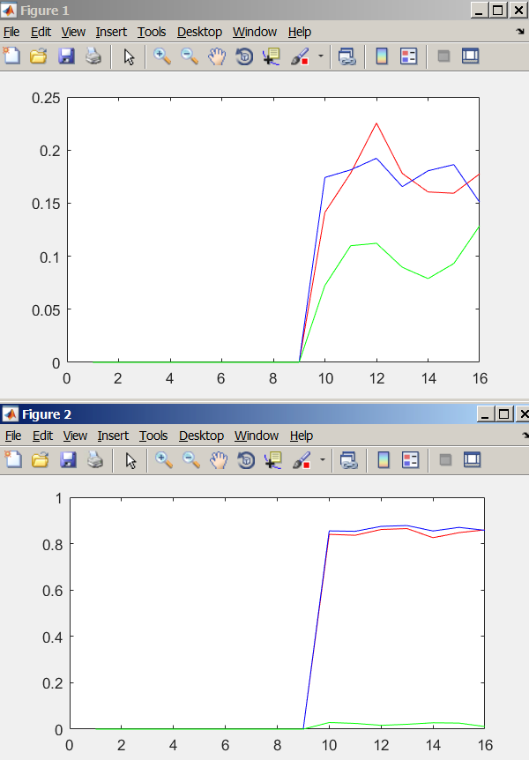

# Appendix

## Part 3.a Matlab Source Code

%% Signal Present Beamformer

%% Data Generation

M = 10;

SNR = [12,13,14,15];

theta = [80,50,-50,-80];

Nmax = 200;

Nmin = 10;

EstimationSize = 200;

alpha1 = zeros(1,Nmax);

alpha2 = zeros(1,Nmax);

alpha3 = zeros(1,Nmax);

r = zeros(M,Nmax);

des = zeros(M,Nmax);

ipn = zeros(M,Nmax);

%repeated for k times to estimate alphas

for k=1:EstimationSize

%% Data Generation for record size N

for t=1:Nmax

E=10*log10(SNR);

D=0:1:M-1;

S_th = exp(-1i*2*pi*(D'*.5)*sind(theta));

b= rand(M,4); b(b>0.5)=1; b(b<=0.5)=-1;

n = randn(M,1);

disturbance= E(2)*b(:,2).*S_th(:,2)+ ...

E(3)*b(:,3).*S_th(:,3)+ ...

E(4)*b(:,4).*S_th(:,4)+ n;

ipn(:,t) =disturbance;

desired = E(1)*b(:,1).*S_th(:,1);

des(:,t)= desired;

r(:,t) = desired+disturbance;

end

rsum = 0;ipnsum = 0;dsum=0;

for i = 1:Nmax

rsum = rsum + r(:,i)*ctranspose(r(:,i));

ipnsum = ipnsum + ipn(:,i)*ctranspose(ipn(:,i));

rr = r(:,i);

dd = conj(des(:,i));

dsum=dsum+ rr.*dd;

end

R= 1/Nmax * rsum;

R_ipn = 1/Nmax * ipnsum;

for N=Nmin:Nmax

rsum = 0;ipnsum = 0;dsum=0;

for i = 1:N

rsum = rsum + r(:,i)*ctranspose(r(:,i));

ipnsum = ipnsum + ipn(:,i)*ctranspose(ipn(:,i));

rr = r(:,i);

dd = conj(des(:,i));

dsum=dsum+ rr.*dd;

end

Rh_ipn = 1/N * ipnsum;

Rh= 1/N * rsum;

w1h = inv(Rh)*S_th(:,1);

w2h = inv(Rh_ipn)*S_th(:,1);

w3h = inv(Rh) * ((1/N) * dsum);

S_th_H = ctranspose(S_th(:,1));

alpha1(k,N) = real((S_th_H*w1h)^2 / ...

((S_th_H*inv(R_ipn)*S_th(:,1))*(S_th_H*inv(Rh)*R_ipn*w1h)));

alpha2(k,N) = real((S_th_H*w2h)^2 / ...

((S_th_H*inv(R_ipn)*S_th(:,1))*(S_th_H*inv(Rh_ipn)*R_ipn*w2h)));

alpha3(k,N) = real(ctranspose(w3h)*S_th(:,1)*S_th_H*w3h / ...

((ctranspose(w3h)*R_ipn*w3h)*(S_th_H*inv(R_ipn)*S_th(:,1))));

end

end

for n=1:Nmax

estAlpha1(n) = (1/EstimationSize) * sum(alpha1(:,n));

estAlpha2(n) = (1/EstimationSize) * sum(alpha2(:,n));

estAlpha3(n) = (1/EstimationSize) * sum(alpha3(:,n));

if(n>M)

estCalcAlpha2(n) = (n + 2 -M) / (n + 1);

else

estCalcAlpha2(n) =0;

end

end

%% Analysis

plot(estAlpha1,'color','r'); hold on;

plot(estAlpha2,'color','b');hold on;

plot(estAlpha3,'color','g');

%plot(estCalcAlpha2,':b');

## Part 3.b Matlab Source Code

How do we measure SNR? The SNR would be measured as the power of a signal’s meaningful information over the power of the background noise. If the variance of the signal and noise are known, and the signal and noise are both zero mean, SNR can be:

1. ***For some ﬁxed SNR values for the user signals, plot your estimated means of α1, α2, and α3 as a function of N from N = 10 to 200.***

Our user signals can be given fixed SNR’s if we assume a distribution for the noise component and if we have a distribution for the signal component.

The signal component would just be the $\sqrt{E_{i}}*b_{i}$, for $i=10,11,…200$ since we will be creating N=200 samples.

$$user signals= \sqrt{E_{i}}*b_{i}$$

We can determine that the SNR with signal absent and signal present:

$$SNR1=\frac{E\left\{{|\sqrt{E_{1}}*b_{1}|}^{2}\right\} + E\left\{{|\sum_{k=2}^{4}{\sqrt{E_{k}}*b_{k}}|}^{2}\right\}}{σ_{noise}^{2}}=E+3E$$

$$SNR2=\frac{E\left\{{|\sum_{k=2}^{4}{\sqrt{E_{k}}*b_{k}}|}^{2}\right\}}{σ_{noise}^{2}}=3E$$

For this BPSK arrangement the average signal power will always equal to $E$.

The noise component will be an AWGN signal and have a variance of 1.

Our SNR optimal would come from the closed form solution for the optimal SNR beamformer applied to the input signals and then the power of that output would be used to calculate SNR again over an AWGN noise . Finally by taking the ratios we can calculate the alpha’s.

We have a beamformer that can give us the optimum SNR in the form of :

$${\hat{\overset{⃑}{w}}}_{maxSNR}=c* {\overset{⃑}{S}}_{θ}$$

We can multiply our received signal by this weight vector and be able to create an output value for each sample N=10 to 200. The output series can then be used to get the average power and divide it by the average AWGN noise power we can get the optimum SNR.

Since we are using a derived series of samples for the signal and for the noise lets use that same series and apply the beamformers for the signal present and signal absent SINR maximization. The outputs of these beamformers should on average equal to E.

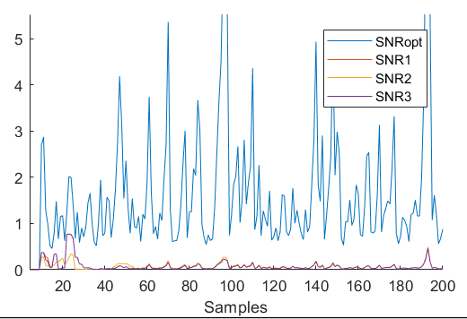

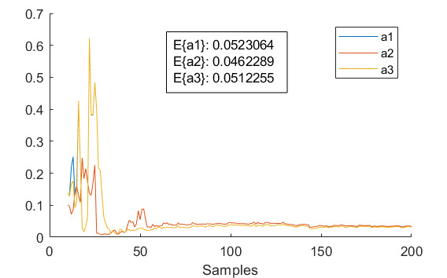

1. ***Keep the SNRs of the interferences as in Part (a) and plot the estimated means of α1, α2, and α3 as a function of the SNR of the user of interest for N = 10,50,100,200.***

We can look at the SNR’s over the optimum as alpha’s 1,2, and 3. The mean of the signals shows us the performance of the simulation. The optimal curves between a1 and a2 can be found algebraically since we know the M and the N.

$$E\left\{α_{2} \right\}=\frac{N+2-M}{N+1} , when (N>M-3)$$

$$E\left\{α_{2} \right\}=\frac{(200)+2-(10)}{(200)+1} =\frac{208}{201}=1.03$$